- Internship Name : Data Analysis
- Task Name: Task 6: Practice NumPy Statistical Functions and Array Reshaping on a Sample Numeric Dataset
- Your Name : Shubhangi Naresh Khonde
- Internship Organization :
- Date:

1.Objective:
The objective of this task was to practice NumPy statistical functions such as sum(), mean(), median(), and std() on a numeric dataset. The task also focused on understanding how to reshape NumPy arrays into different row and column structures using the reshape() function.

2.Introduction:
NumPy (Numerical Python) is a powerful Python library used for numerical computing and data analysis. It provides efficient data structures called arrays and various mathematical and statistical functions.
In this task, a sample numeric dataset was created using NumPy arrays. Statistical operations were performed to calculate the total, average, median, and standard deviation of the dataset. The array was also reshaped into different dimensions to understand how NumPy manages multidimensional data.

3.Concepts Covered:
The following concepts were practiced during this task:
- Importing NumPy
- Creating NumPy arrays
- Calculating the sum of array elements
- Calculating the mean or average
- Finding the median
- Calculating standard deviation
- Understanding array dimensions
- Reshaping arrays using reshape()
- Working with rows and columns in a NumPy array

4.Tools Used:
- Python
- NumPy
- Jupyter Notebook
Code / Implementation

5.Code / Implementation:
1. Importing NumPy:
import numpy as np
NumPy was imported using the alias np, which makes it easier to use NumPy functions.
2. Creating a Sample Numeric Dataset:
marks = np.array([65, 70, 75, 80, 85, 90, 95])
print(marks)
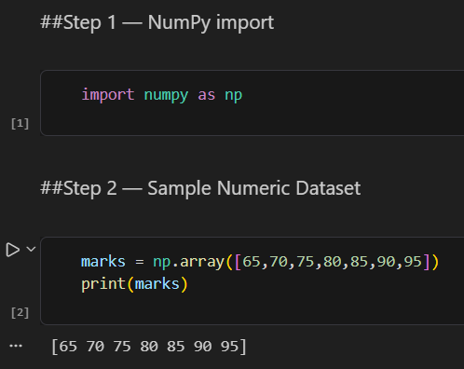
The above code creates a NumPy array containing sample student marks.

3. Calculating Sum and Mean:
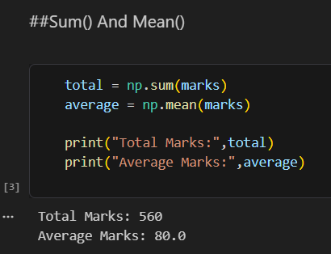

The np.sum() function calculates the total of all values, while np.mean() calculates their average.

4. Calculating Median and Standard Deviation:
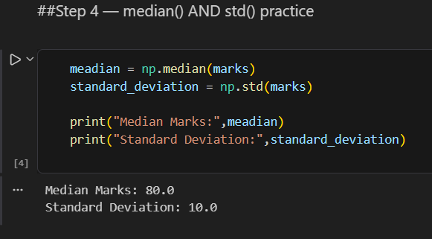
The np.median() function returns the middle value of the dataset, while np.std() measures the spread or variation of the data.

5.Creating an Array for Reshaping:
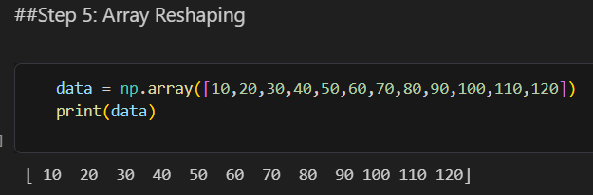

6. Reshaping the Array into 3 × 4:
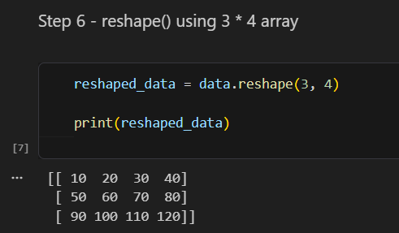
The array contains 12 elements. It was reshaped into 3 rows and 4 columns.

7. Reshaping the Array into 4 × 3:
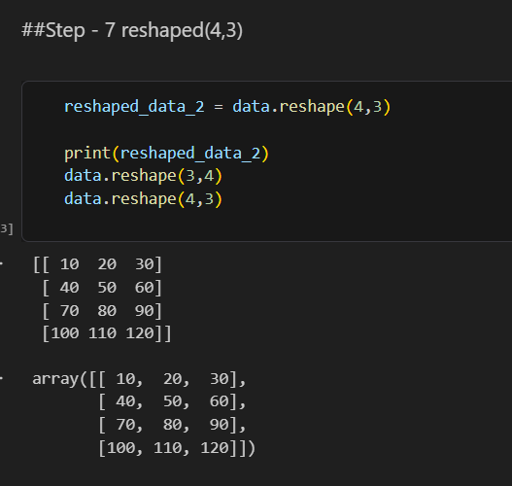
The same 12 elements were rearranged into 4 rows and 3 columns.

8.Final Combined Practice:
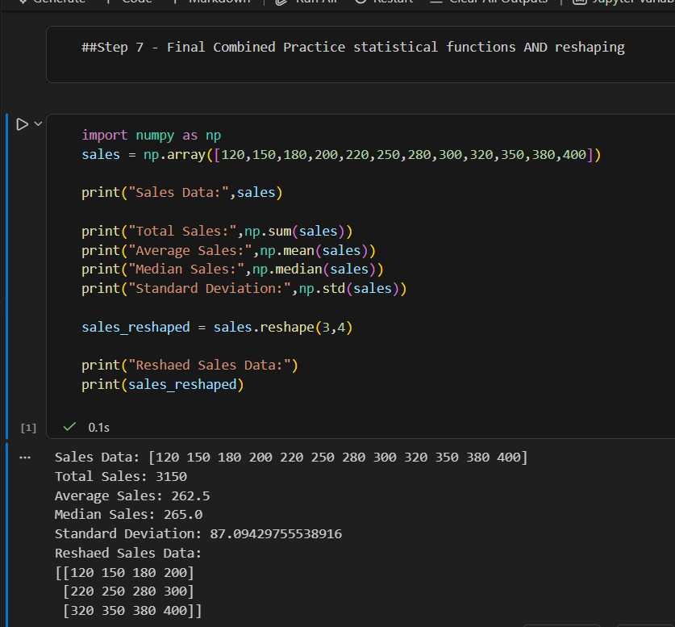
The statistical analysis and array reshaping were successfully performed.
Operation | Result
Total Sales | 3330
Average Sales | 277.5
Median Sales | 265.0
Standard Deviation | Approximately 88.67
Reshaped Array | 3 × 4
The sales array was successfully converted from a one-dimensional array into a 3 × 4 two-dimensional array.

9.Results:
The task was successfully completed using NumPy. The sample numeric datasets were analyzed using statistical functions. The total, average, median, and standard deviation were calculated successfully. The array was also reshaped into different dimensions while maintaining the same number of elements.

10.Key Learning:
Through this task, I learned:
- How to create and work with NumPy arrays.
- How to calculate the total using np.sum().
- How to calculate the average using np.mean().
- How to find the middle value using np.median().
- How to measure data variation using np.std().
- How to change the dimensions of an array using reshape().
- The importance of maintaining the correct number of elements while reshaping an array.
- How NumPy statistical functions can be useful in data analysis.
11.Conclusion:
This task provided practical experience with NumPy statistical functions and array manipulation. I successfully calculated statistical measures such as sum, mean, median, and standard deviation on numeric datasets. I also learned how to reshape one-dimensional arrays into two-dimensional structures using the reshape() function. These concepts are important for data analysis and will be useful in further Python and data analytics tasks.

